TO: Tim , Division Analyst

FROM: Bryce Forseth, DBA / Data Analyst

DATE: 4/11/2025

SUBJECT: Automation of Bike Sales Reporting: Total and Percentage Breakdown by Country

This memo outlines the data management and reporting solution developed to automate the regional bike sales report previously maintained manually in Excel. With the decommissioning of SAP and transition to Workday, the original reporting process was interrupted, leading to a increase in manual effort. In response to this issue, I have created a SQL-based solution that consolidates country-level sales data, aggregates product-level information by bike model, and produces two versions of the required report.

The first objective was to bring together data from five country-specific tables, and comebine them into a data set, BikeSales_All From this unified dataset, I created two SQL based reports to replicate the previous Excel pivot tables. The first report provides total unit sales by country and model. The total values were then added to create a Grand total column, which consisted of the total unit sales from all 5 countries (See Table 1 below).

**Table 1**

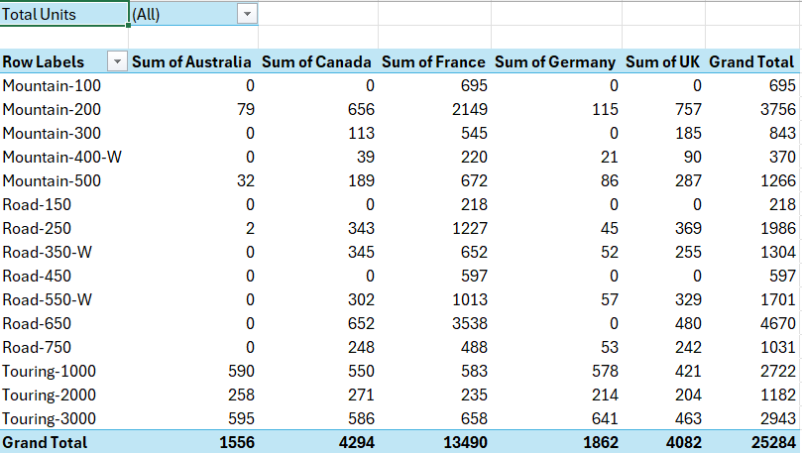

The second report provides the same data but reformatted as percentages to show each model’s distribution of sales across the five countries. Using a similar array and pivot approach, I calculated percentage values by dividing the country-level sales by the total units sold per model. This allowed each row to sum to 100 percent. A view of this table can be seen below (See Table 2).

**Table 2**

A view of all SQL used to create these tables can be found in the Appendix. These tables were copied into excel, to make it easier to view as the same format the old system used.

**Appendix**

